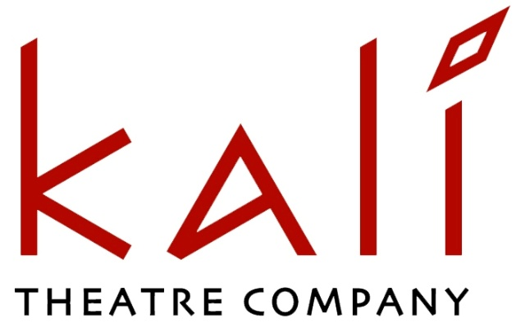
Intrepid plays by fearless women

ARTISTIC DIRECTOR & JOINT CEO
RECRUITMENT INFORMATION

Welcome from the Chair of Kali Theatre

Thank you for your interest in Kali Theatre and the position of Artistic Director, which has become vacant after the very sad death of Helena Bell.

I am pleased to be able to provide you with information on the Company that, over 30 years, has led the way in developing stories of women writers of South Asian descent. Many Kali Theatre writers have gone on to work in theatre, television and film, and have had a profound and positive impact in telling their stories and enriching audiences’ experiences.

We are seeking a bold and visionary leader who is passionate about supporting women writers of South Asian descent. Whilst you will have a knowledge of the challenges and barriers that exist, you should be excited to drive forward our mission and lead Kali Theatre into its next exciting chapter.

In this recruitment pack you will find information about Kali Theatre, its vision and mission, details of past work and future commitments, the Artistic Director’s job description and person specification, and details of how to apply for the position.

Alison McFadyen
Chair - Kali Theatre

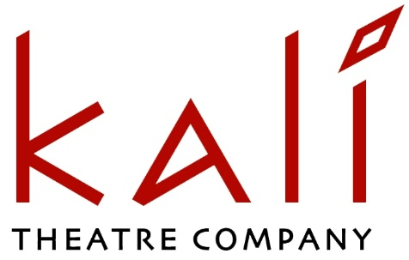

Mission
Kali Theatre develops and presents groundbreaking, thought provoking, contemporary theatre by women and writers of South Asian descent that reflects and comments on our lives today.

We work to:
• Inspire, develop and nurture women writers of South Asian descent
• Present high quality thought provoking new plays that challenge perceptions
• Reach out and develop South Asian audiences across the UK
• Attract new theatregoers for diverse work from all backgrounds
• Diversify the programming of mainstream theatres
• Provide leading roles for South Asian actors to showcase their skills and inspire more diverse casting
• Provide directing opportunities and training for female theatre directors of South Asian descent
• Develop regional, national and international partnerships to support the development and extend the reach of our work.

For over 30 years, Kali Theatre has been at the forefront of increasing South Asian representation in British theatre. We nurture talented writers who challenge perceptions, bringing their experiences and stories to audiences from all backgrounds. Our writers connect us to South Asian communities and bring their lived experience to the stage.

Many of Kali Theatre’s writers have gone on to work with other theatres, television and film companies, and have had a significant positive impact on making contemporary drama reflect the diversity of modern Britain and enrich its cultural life. Over the last six years, 48 writers have been supported to create or develop new plays. 32 of them had not previously had plays professionally presented.

Our work increases opportunities for South Asian women to work in creative leadership roles in theatre, and our performances increase the representation of British South Asian actors by showcasing them in non-stereotypical roles.

Our venue partnerships have grown, including collaborations with Southwark Playhouse; Birmingham Repertory Theatre; Coventry Belgrade Theatre, Leicester Curve; Leeds Playhouse, Northern Stage, Tara Theatre, New Earth Theatre, Tamasha Theatre. In Autumn 2025 we will co-produce a new play with Soho Theatre.

Kali Theatre is an Arts Council England National Portfolio Organisation, with an annual turnover in 2024/25 of £280,000, an Ethical Manager member of the Independent Theatre Council and a resident company at The Albany, Deptford.

In a close-knit team, the Artistic Director works with the Executive Director (and joint CEO) to manage the company and deliver its programme, supported by a part time Administrator.

We are seeking a bold and visionary leader who is passionate about championing women writers of South Asian descent. Whilst you will have a knowledge of the challenges and barriers that exist, you should be excited to drive forward our mission, develop an ambitious artistic programme and lead the company into an exciting new chapter.

Artistic Policy and Programme
Kali Theatre inspires, develops and presents groundbreaking, thought provoking, new plays by women writers of South Asian descent that reflect their stories and experience and comment on our lives today.

It places equal emphasis on presenting an annual full production and delivering new play development programmes that discover and showcase new writers and provide support to more established writers to develop ambitious new plays. The Board wish to see this core policy continue. The incoming Artistic Director will shape how this policy is implemented in the future, with the Board’s agreement.

Recent Activity
2020 Kali SOLOS: 15 short films commissioned from Kali writers in response to the Covid-19 crisis - performed & recorded in isolation by Kali actors.

2021 On the Shoulders of Kali Symposium: Over 100 delegates and speakers marked 30 years of championing South Asian women writers.
THIRTY, featuring monologues and duologues from past KTC plays
was published by Methuen to celebrate the 30th anniversary.

2022 Noor: Performed at Southwark Playhouse
Discovery 2022: 6month programme that sought out 12 talented new writers, culminating in showcase readings of short plays. Partnership with Hampstead Theatre, Oldham Coliseum & Leeds Playhouse.

2023 Phantasmagoria: 4week run at Southwark Playhouse, plus on tour to Coventry Belgrade Theatre, and Newcastle Northern Stage.
International Plays: A week of script-in-hand performances of five cutting-edge new plays with thought provoking, global themes. Four UK playwrights and a writer from India explored what it means to be part of a wider landscape from the unique perspective of female and non-binary writers with a South Asian background.

2024 Discovery 2024 with Theatre 504, Leicester Curve & Birmingham Rep
King Troll (The Fawn): A dystopian tale about the corrosive impact of state racism and the monster within. 4 weeks @ New Diorama Theatre .
March 29 SEEDLINGS: A day-festival of new theatre and discussion exploring the impact of the Climate Crisis on the Global South, in partnership with New Earth & Tara Theatre.

Future Programme
Autumn 25 Period Parrty by Gayathiri Kamalakanthan.
Co-production with Soho Theatre. Directed by Gitika Buttoo
Discovery Plus: Play development programme in Bradford & London Culminating in script-in-hand performances of new work.

Autumn 26 Empire of the Mind by Satinder Chohan - a co-commission with
Tamasha Theatre currently in development

- Kali Writers Forum: Online two monthly meeting for South Asian women writers
- Queer Writer Workshops: Series of workshops primarily for LGBTQ+ writers
- Assistant Director Placement: Development opportunity to support the progression of South Asian women practitioners towards become a director
- Dramaturg Training Scheme: Addresses the lack of South Asian representation among Dramaturgs and Literary Associates.

ARTISTIC DIRECTOR & JOINT CE0
JOB DESCRIPTION
Purpose
The Artistic Director has overall responsibility to lead on the planning and delivery of an ambitious and effective artistic programme, in line with the current artistic policy, driving innovation and creativity, to inspire, develop and promote the creativity of women writers of South Asian descent.

The Artistic Director is appointed by and responsible to the Kali Theatre Board
Reporting to: Chair of Trustees
Responsible for: Creative Teams and freelance artists
Working with: Executive Director / co-CEO.

Terms and Conditions
Hours of work: Permanent, full time 40 hours per week.
Some unsocial and weekend hours
Salary: £42,000pa gross less PAYE tax and NI
Holiday: 25 days paid holiday to be taken when the company is not in
production, plus statutory bank holidays
Location: Hybrid working with a minimum of 2 days per week in the office. at The Albany, Deptford
Plus ~ 10days/year away at tour venues when required
Pension: 3% Employee Contribution. 5% Employer contribution. NEST.

Kali Theatre encourages and supports staff to take up professional development, mentoring and networking opportunities.

The Artistic Director will
- Assume artistic leadership and management of existing planned programme
- Plan the details and deliver a new play development programme to start in October 2025 – and culminate in readings in March 2026
- Devise, develop and deliver the overall artistic programme for Kali Theatre beyond this, in line with the core artistic policy and subject to Board approval
- Manage Kali Theatre’s artistic operations including support and supervision of all engaged creative personnel
- Lead and manage Kali Theatre’s writer support programmes
- Direct the annual production or act as a Creative Producer to support and supervise an external director and creative team
- Together with the Executive Director/joint CEO, be responsible for delivery of agreed Arts Council Outputs and embedding of ACE Investment Principles
- Work with the Executive Director to adjust planning for all activities to maintain a balanced annual budget

Artistic Planning and Vision
- Develop and implement an ambitious and distinctive artistic vision that aligns with Kali Theatre’s mission and values, delivering artistic excellence and a strong company identity
- Plan and deliver a high-quality artistic programme, including commissioning and developing new plays that resonate with contemporary audiences.

Implementing Artistic Policy
- Establish and maintain artistic standards and quality for all productions, ensuring they reflect the theatre’s commitment to diversity and innovation
- Guide and support writers, directors, actors, designers, and other creative personnel to achieve the highest production standards
- Commission writers and support their development process
- Initiate and cultivate new creative and strategic partnerships and collaborations to further Kali’s mission.

Executive Management
- Collaborate with the Executive Director to set the strategic direction of the company, ensuring financial sustainability and operational excellence
- Contribute to the development of funding applications.

Liaison with Board
- Report quarterly to the Board of Trustees on artistic activities, strategic developments, and organisational progress, monitoring the company’s overall delivery of the strategic direction and business plan
- Liaise with Board Chair at other times as required to report and/or seek approval.

External Liaison
- Be an advocate/spokesperson for the company, ensuring that the company’s work is clearly articulated at public events, promotional /fundraising activities
- Foster relationships with other cultural organisations, potential co-producers, donors, and community stakeholders to enhance the theatre’s profile and outreach.

KALI THEATRE ARTISTIC DIRECTOR - PERSON SPECIFICATION

Essential skills and experience
- Commitment to and empathy with the ethos of Kali Theatre
- Enthusiasm for new writing, and experience and understanding of the development process either as a writer, director or dramaturg
- Experience of creating, directing, producing / curating and touring high quality professional theatre
- Experience of and commitment to nurturing talent in emerging artists
- The ability to lead with good negotiation skills, with some experience of negotiating contracts
- Strong track record in forging exciting creative relationships and collaborations to develop new work
- Proven planning and organisational skills with a good record for managing multiple projects, working to deadlines and responding well to pressure
- Good advocacy skills, and able to influence, create dialogue and champion
- Understanding of and commitment to equal opportunities
- Experience of working with a Board.

Personal qualities and attributes
- An awareness of the challenges women face in the theatre industry and within South Asian cultures
- Good knowledge of South Asian culture
- Passion for new writing and new work
- Strong interpersonal skills, a natural collaborator and team player
- Ability to lead, motivate and inspire others
- High level of resilience and resourcefulness and a creative problem solver
- Demonstrable commitment to diverse artistic practice and supporting new talent
- Able to manage multiple priorities
- A natural and engaging communicator.

Desirable skills and experience
- Budgeting, with the ability to align artistic ambitions with financial realities.
- Experience of raising funds from trusts, foundations, individuals and partnerships
- Understanding of marketing and promoting the arts
- Excellent knowledge of contemporary culture, especially in relation to theatre
- Good IT skills
- Strong national / international networks
- Knowledge of Arts Council England’s Let’s Create strategy, including Outcomes and Investment Principles.

We are committed to talent development and will support emerging leaders who meet key essential requirements to develop and grow into the role, rather than expecting applicants to come fully formed.

If you would like to arrange an informal phone/Zoom conversation about the role while considering whether to apply, please email Executive Director Chris Corner chris@kalitheatre.co.uk
With ‘Kali AD conversation’ in the subject line.

HOW TO APPLY
Your application must include your full CV and a separate covering letter of no more than 3 pages, describing how your personal and professional skills and experience meet the job description and person specification, and what you would bring to the role.

Your application must include contact details for two referees who will be consulted after the second interview.

Please email your application to chris@kalitheatre.co.uk
With ‘Artistic Director Application’ in the subject line.
If you do not receive email confirmation of receipt within 4 working days please call or text Chris Corner on 07850 875546

Deadline for applications Monday 19 May @ 12midday
1st Interviews Saturday 7 June
2nd Interviews Saturday 21 June

The role is expected to start full-time by September/October on a date to be agreed.
With 3-4 days across the summer planning details of a new play development programme to start in October. (Paid pro-rata)

We are committed to meet the access needs of all candidates through the recruitment process and for our staff in post. Please let us know how we can make any necessary adaptations to meet your requirements, and we will provide suitable support to the best of our ability.

